# User manual

1. Run the software. Then enter the product and click submit. Move over to Graph Tab, use zoom in the graph and then go to data tab

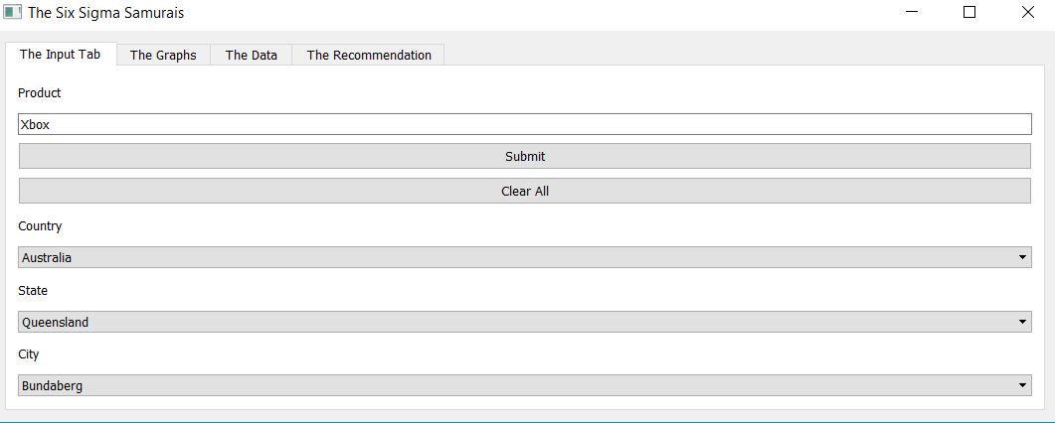

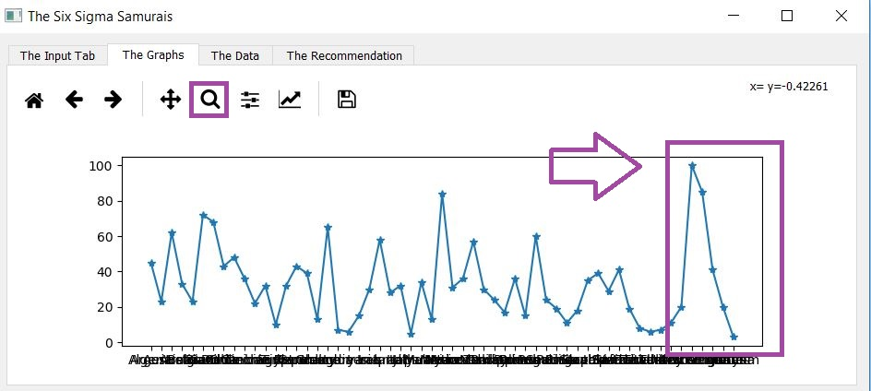

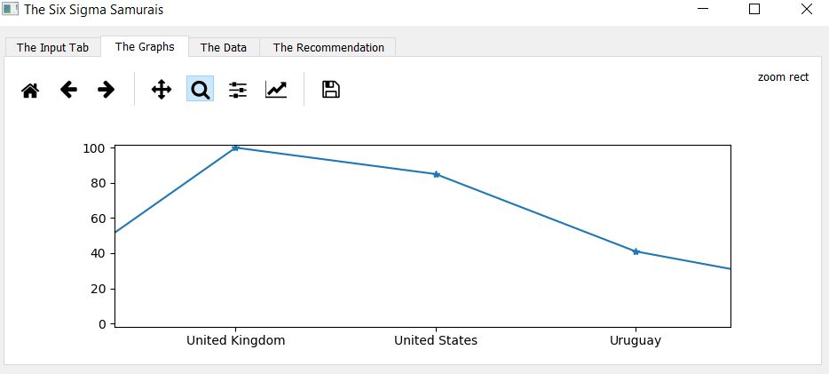

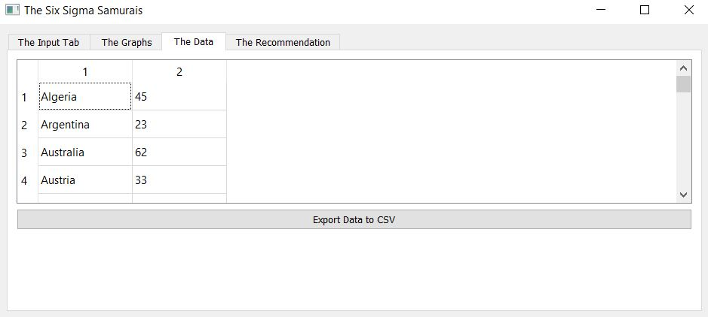

1. Select the country you want to search. Repeat the previous steps to see graph and data.

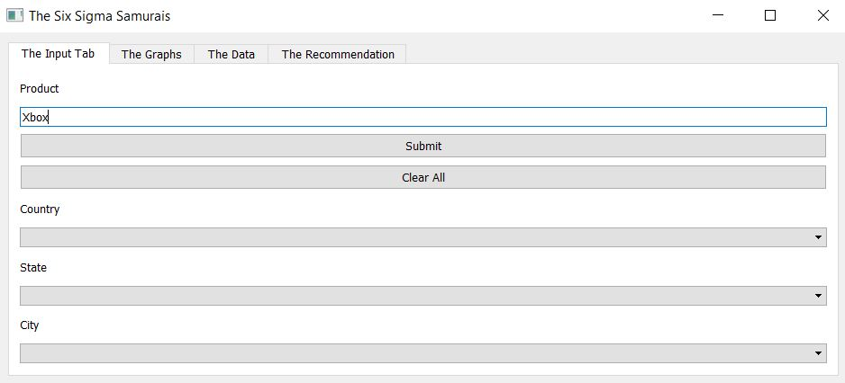

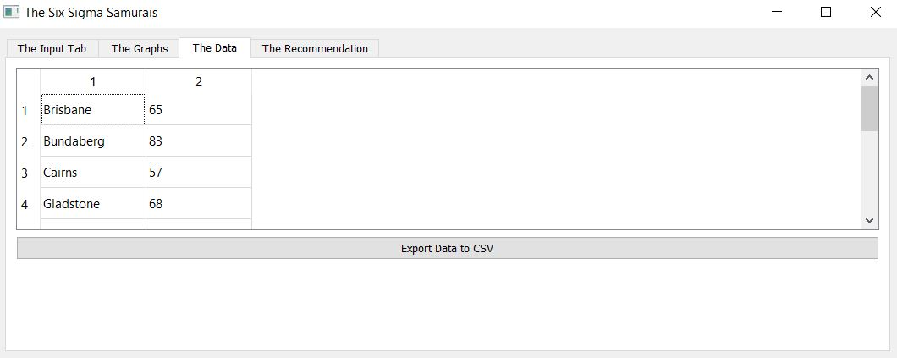

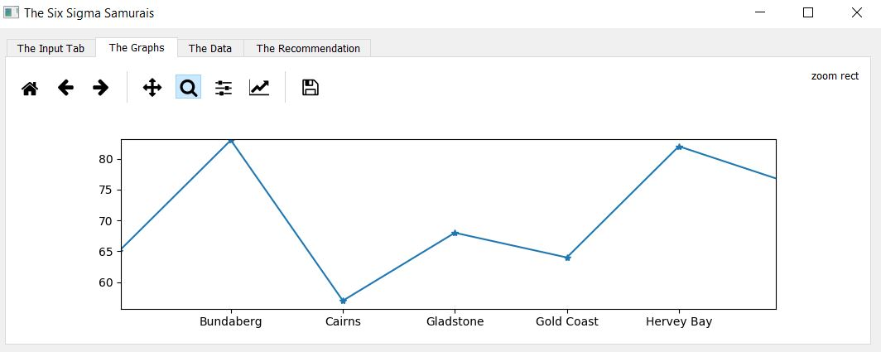

1. Select the state you want to search. Repeat the previous steps to see graph and data.

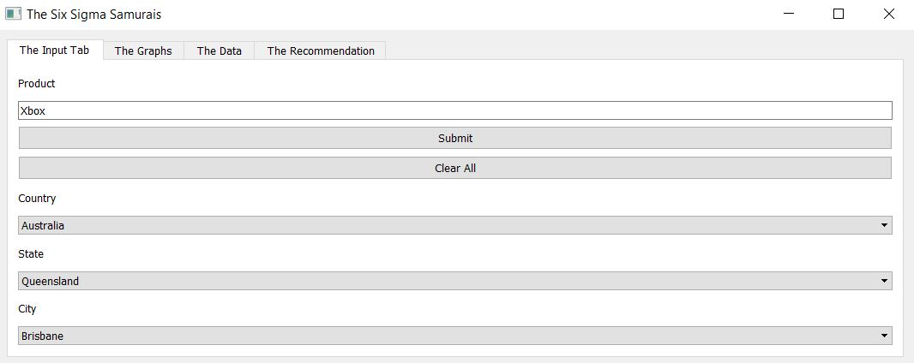



1. Select the city you want to search. Then go to recommendation tab to see total number of users searching for the keyword.



